Game Design Document:
OVERVIEW
- Version 1.0 -

By
Randy Prieto

Copyright © 2014 Retrovert Games
All rights reserved

Contents

Contents A
Change Log C
What is this Document? D
Game Summary 1
What’s an “Arachnoid?” 1
Plot Summary 2
Perspective 4
Genre 4
Projected rating (ESRB) 4
Target platforms / distributors 4
Player Mode 4
Game Speed 5
Win condition 5
Loss condition 5
Gameplay Hooks: What makes Arachnoid awesome? 6
Omnidirectional Platforming! 6
Weapons! 10
Abilities! 15
Upgrades! 17
Exploration! 19
Story - Characters 21
Vincent Ross 21
Floid McRoid 21
Simon “Sid” Marshall 22
Olesya Belikov 22
Story - Dialogue (partial) 23
Legend 24
Prologue 25
(0.1) 25
(0.2) 27
(0.3) 35
(0.4) 41
Chapter 1 54
(1.1) 54
(1.2) 54
(1.3) 56
(1.4) 62
(1.5) 63
(1.6) 65
(1.7) 68
(1.8) 75
(1.9) 79
Appendix 86

Change Log

Version | Date published | Changes
1.0 | 10/9/14 | Initial publication to RetrovertGames.com

What is this Document?

This document is a rough overview of Arachnoid’s design - it doesn’t go into great detail about any specific game mechanics; I’m leaving those for another (much lengthier / more technical) document.
It’s primarily meant to briefly explain what Arachnoid is and what makes it awesome.

Note:
At the time of this document’s publication, Arachnoid is still in the
design phase of development, and everything outlined in this document is subject to change!

For more Arachnoid updates:

Visit the website: www.RetrovertGames.com
Follow on Twitter: @RetrovertGames
Like on Facebook: www.facebook.com/RetrovertGames

Game Summary

What’s an “Arachnoid?”

“Arachnoid: Integration” is the full title of this game.

The term “Arachnoid” is comprised of the root-word “arachnid” (meaning spider) and the suffix “-oid” (meaning -like).
So, “Arachnoid” literally means “spider-like.”

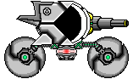

In the game, an Arachnoid is a super advanced, small, highly mobile, tank-like vehicle. One of its most notable traits is its ability to manipulate its own gravity, enabling it to move over floors, walls, and even ceilings - much like a spider can.

Plot Summary

Arachnoid: Integration is a game that follows the story of the Nomad - a deep space explorer ship manned by a crew of four.
The captain of the Nomad (and protagonist - Vincent Ross) and his crew are suddenly attacked one day while orbiting a remote planet in deep space. They’re forced to make an emergency landing on the surface of a planet code-named
“AR-04.”
Unsure of who their attackers are or even why they were attacked to begin with, the Nomad crew inspects their ship and finds that various systems have been damaged, but worst of all, the Nomad’s primary power source - its Power Core - has been destroyed beyond repair.
However, by an incredible stroke of luck, their ship’s scanner detects a small quantity of Eurozium nearby - a substance that they can use to create a new Power Core for their ship.
Vincent knows that, without a new Power Core, their only option would be to wait for a rescue ship to come and save them.
Unfortunately, that could take months…
And so, Vincent sets out in search of the Eurozium, which brings him to a cave.
Inside, he finds what appears to be a small, tank-like vehicle - the Arachnoid. Though it seems to have been abandoned many years ago, the Arachnoid is, surprisingly, still operational.
Armed with this strange machine, Vincent continues on, deeper into the cave, in search of the Eurozium.
It doesn’t take long, however, for Vincent and his crew to realize that AR-04 is much more dangerous than they had anticipated… and that the Arachnoid is their only hope for survival.

Initially, very little is understood about their new surroundings, however, as Vincent delves deeper into the mysterious planet, gathering Eurozium along the way, the crew of the Nomad slowly begins to understand the truth about AR-04, its previous inhabitants, and, of course… the Arachnoid.

Perspective
2D Side-scroller

Genre
Adventure,
Platformer,
Shooter

Projected rating (ESRB)
Mature (1):
- Blood
- Strong language
- Violence

Target platforms / distributors
Primary:
- Playstation 4 - Playstation Network digital download
- Playstation Vita - Playstation Network digital download
Secondary:
- Windows PC - Steam digital download

Player Mode
- Offline - will not require an internet connection to play
- Single-player only

Game Speed
Real time - players’ ability to react and adapt quickly to new situations will be crucial to their survival as enemies will actively pursue and attack them

Win condition
Player successfully completes all levels and defeats all bosses
(Note: the game features multiple endings)

Loss condition
Player HP drops to 0

Gameplay Hooks:
What makes Arachnoid awesome?

Omnidirectional Platforming!

The Arachnoid (the player) is able to invert its own gravity by using its Gravity Jump ability (which is acquired very early in the game).

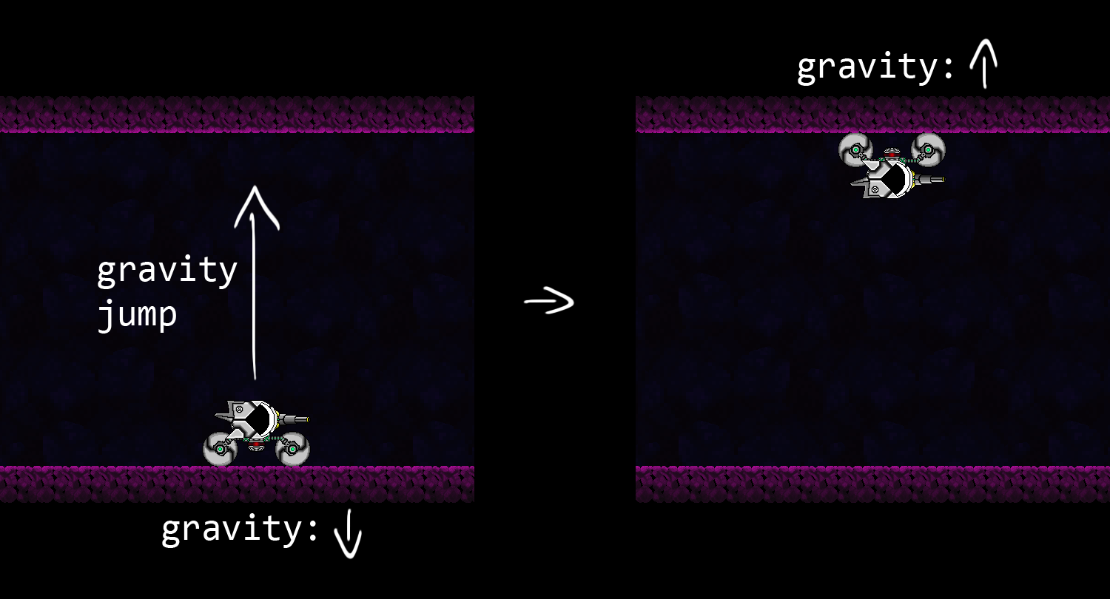
The Gravity Jump ability can only be used to jump directly onto another surface, however, and it has a limited range (which is expanded later in the game).

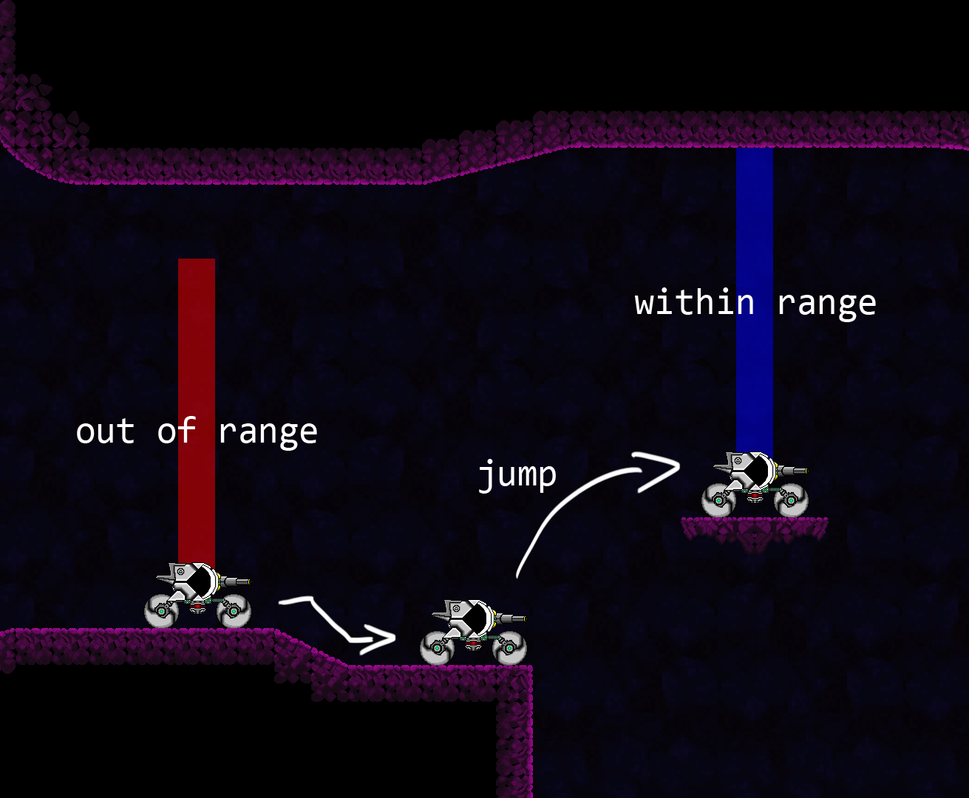
The Gravity Jump ability also forces the Arachnoid to transition over curved surfaces onto adjacent walls…

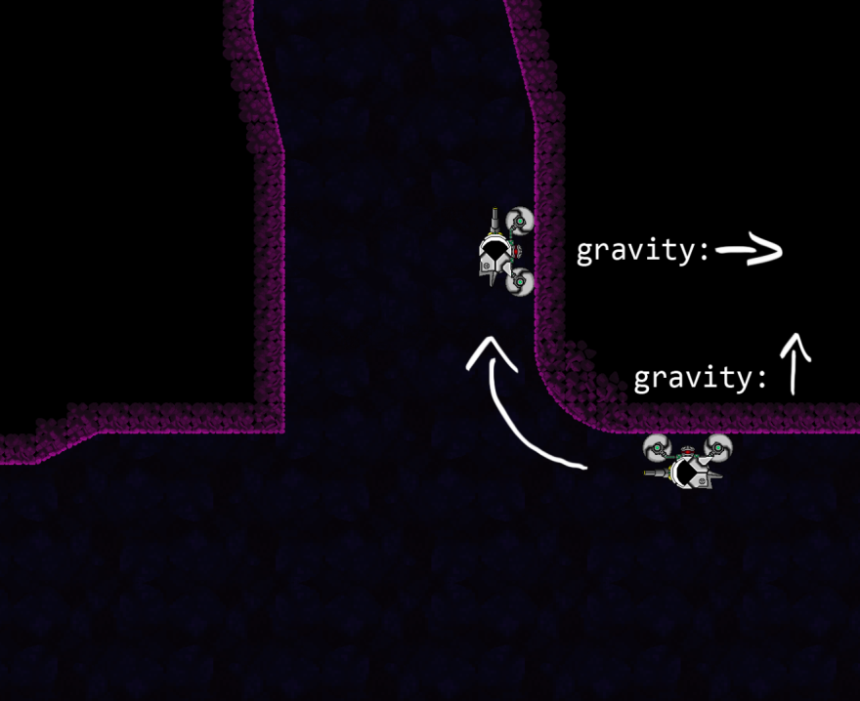

…but it cannot make that transition over sharp edges or cliffs.

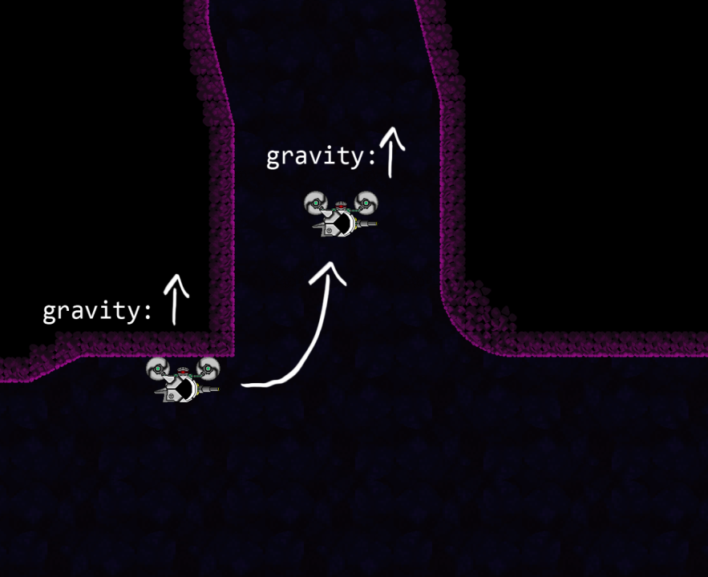
And because the game features a fixed camera perspective (i.e. the camera does not rotate with the player), the player will have to learn to quickly adapt to the ever-changing gravity to progress through levels and during combat.

Designer notes: Omnidirectional Platforming
These specific limitations on player movement (particularly regarding gradual curves and sharp edges (see above)) enable some very interesting level design possibilities…
My theory is that if players were able to move around too freely (i.e. if the Arachnoid could jump extremely high or the Gravity Jump ability didn’t require a target surface to be within range), then platforming-based puzzles would be much easier to solve… and that’s no fun. (sad face)
Note: I’ll go into greater detail of how this mechanic will work in a later document.

Weapons!

The Arachnoid comes equipped with a Primary Cannon, but it can also utilize a Secondary Cannon (acquired early in the game).
Both cannons are controlled simultaneously (i.e. both cannons will always be aiming at the same target), but they are both fired individually
(i.e. both cannons have their own separate fire buttons).
This gives the player much more freedom when fighting multiple enemies.
Primary Cannons can be fired continuously (at their own individual rates of fire) and they can all be charged 2 stages to fire more powerful shots.
There are 4 unique, interchangeable, front-mounted Primary Cannons to use:

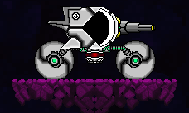
The Breaker Cannon (default) is a well-rounded, all-purpose weapon.

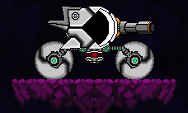
The Burst Cannon lacks range, but it compensates for that with its large blast-radius. It can also knock back enemies.

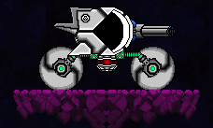
The Rapid Cannon is unsuited for multiple targets, but its single-target capabilities are unmatched.

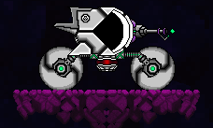
The Beam Cannon’s shots, although relatively weak, can pierce through multiple targets as well as bounce off of walls for multiple strikes. With precise aiming, the Beam Cannon is capable of dealing incredible damage.
In addition to the 4 Primary Cannons, there are also 10 interchangeable, rear-mounted Secondary Cannons to utilize.
Unlike Primary Cannons, Secondary Cannons cannot be fired continuously; they all share a single, self-replenishing energy source (which is displayed around the aiming reticle).

The first 9 Secondary Cannons can be found during normal gameplay.
The final (and most powerful) Secondary Cannon can only be obtained in New Game+, however.

The New Game+ feature will allow players to begin a new game while importing all acquired weapons and upgrades (but not abilities) from a previous CLEARED GAME save file. It will feature a greatly increased difficulty level as well as drastically altered enemy placement.
Designer notes: Weapons
While I was designing the Primary Cannons’ functionalities, I made a full damage chart for each weapon and each of their charge stages. According to the numbers I have right now (which take into account things like the ability to pierce enemies, number of bounces (Beam Cannon), base damage, and max. rate of fire), all of the Primary Cannons are fairly balanced… but, of course, this all needs to be tested in-game.
My goal is for each Primary Cannon to be useful and balanced, and for them to have strengths / weaknesses based not on numerical values, but the current situation that the player is in.
For example, the Breaker Cannon doesn’t have any major strengths or weaknesses, so it makes for a good default, I’m-still-learning-how-to-play-the-game weapon. It’s a decent weapon in all situations.
The Burst Cannon does some great area damage, and the Rapid Cannon’s great against single targets.
I especially had a lot of fun designing the Beam Cannon, though. I decided that, because its effectiveness relies so heavily on player skill (and nearby surfaces), it should have the highest potential damage output.

Again, though, despite all of my calculations… all of this needs to be tested.

Abilities!

Thare are 12 abilities to find in the game; each one increasing the Arachnoid’s offensiveness, defensiveness, or mobility.
Here are 4 of them:

Booster:
Enables Arachnoid to perform a short forward thrust.

Hover:
Enables Arachnoid to perform a short, sustained upward thrust.
Operates on Hover Energy which, once used, automatically replenishes itself over a short time.

Flash Booster:
Enables Booster to be charged to perform a Flash Boost, which propels the Arachnoid much farther/faster forward and can burn through certain obstacles.
Also damages and knocks back enemies on contact.

Tread Spines:
Maximizes traction on frozen surfaces and enables Arachnoid to Gravity Jump onto frozen surfaces.
Also allows Arachnoid to run over and destroy small enemies and increases Gravity Jump contact damage.
Designer notes: Abilities
Almost every ability designed allows the Arachnoid to overcome some specific obstacle (and reach new areas). Aside from that, though, I made a concerted effort to incorporate offensive upgrades into as many abilities as I could.
Not every ability gained will directly increase the Arachnoid’s offensive capabilities (such as the Hover ability), but I think that, because combat is such an integral part of Arachnoid’s gameplay, feeling the Arachnoid gain strength and grow as players progress through the game will help keep gameplay fresh and interesting.
Not only that - as the player acquires new abilities, the Arachnoid sprite (image) will also be updated. This way, players will see the Arachnoid grow, as well.
(Note: I’ve kept the Arachnoid sprite completely segmented, meaning that it’s actually a sprite made up of many smaller, individual sprites. This should make changing the sprite (as players gain new abilities) a relatively simple process.)

Regarding level progression, I personally really like having to find new abilities to overcome new obstacles. Not every level will follow the basic formula of (encounter new obstacle X; gain new ability Y to overcome X), but it can be a great way to guide players through a game (especially an open-world game) if you (the level designer) are really careful about how you design new obstacles / abilities.
PS - Super Metroid’s level design rulez.

Upgrades!

The Arachnoid can be upgraded in 3 distinct ways:
- The Arachnoid’s Core (HP) may be expanded by defeating bosses and also by collecting Core Expansions (which are scattered all throughout the planet). Additionally, as the Arachnoid’s Core expands, its Primary Cannons will also become more powerful.

- Chips may also be applied to Primary Cannons to boost damage, increase shot count, and, among other things, add special effects to Primary Cannon bullets such as splash damage, pierce, and knock back.

- Plugs may be applied to Secondary Cannons to increase bullet damage, reduce energy consumption, and decrease Cannon swap time (which applies only to Secondary Cannons).
Designer notes: Upgrades
Primary Cannons:
Each Primary Cannon Chip is unique, but the same Chip may be equipped onto multiple Primary Cannons. (i.e. because each Primary Cannon is unique, each one will have its own unique Chip load-out, and a single Chip may be equipped onto multiple Primary Cannons simultaneously).
Note: This is just for players’ convenience.

Primary Cannon Chips may be equipped / switched at any time during gameplay (in the “Weapons” menu).

Secondary Cannons:
There are 3 types of Plugs that may be applied to any Secondary Cannon, however Plugs only affect the specific Secondary Cannon that they are applied to (i.e. Secondary Cannons are upgraded individually; one Secondary Cannon’s upgrades will not affect another’s).

Secondary Cannon Plugs may only be equipped / switched in Maintenance Rooms (save points) and at the Nomad (the player’s ship).

I think this system will allow for a high degree of versatility in Primary Cannons and will also give players the opportunity to experiment with their various Secondary Cannons while still having to choose carefully which Secondary Cannons to upgrade and proceed through the game with.
For instance, if a player finds a particular Secondary Cannon to be ineffective in a particular level, he or she may visit a nearby save point, remove all Plugs from the ineffective Secondary Cannon, and apply them to another one without penalty.

Exploration!

There are many items to be found throughout the massive world of AR-04, including weapons, Core (HP) Expansions, Primary Cannon Chips, and Secondary Cannon Plugs.

The various levels of Arachnoid will be designed to heavily encourage backtracking. For example, there are many areas in level 2 that are only accessible with an ability acquired in level 5.
This will ensure that players will have plenty of opportunities to explore (and possibly gain new weapons and upgrades) if they feel they’re yet not strong enough to progress to the next level.
Design notes: Exploration
Although exploration and backtracking are strongly encouraged (and rewarded), AR-04 is not an open world; that is, there is a specific order that sub-areas (levels) must be progressed through.
There are two major reasons for this linearity:
The first reason is that Arachnoid’s story is so dependent on certain events happening in a specific order. If players were able to skip levels or complete them in any order, then most of the game’s cutscenes (which often reference previous cutscenes) wouldn’t make sense. In other words, Arachnoid: Integration features a deep, progressive story.
The second reason lies in the game’s progression design. Rather than blocking off areas with numbered doors (for example), I’ve decided to block certain paths with obstacles that can be overcome with specific abilities that are gained at specific points in the game. In other words, I prefer a system in which level 4 is accessible only after the player gains the Hover ability, which is obtained in level 3.
Another advantage of this system is that it ensures that players actually obtain abilities before they’re able to wander into areas that require their use.

I’d previously designed the first 3 levels in Arachnoid, but at the time of their design, I was under a very fast-approaching deadline (my college senior project presentation). I still like their basic designs, but now that I don’t have nearly as many design constraints, I’ll be re-designing them to be more intricate and expansive.

Story - Characters

Vincent Ross
Sex: M
Age: 27
Occupation: Nomad Captain / Pilot, Arachnoid Pilot

A skilled starship pilot and Captain of the Nomad, Vincent’s very well-respected in the Explorer community. He tends to work well under pressure and he’s fiercely protective of his crew.

Floid McRoid
Sex: M
Age: 20
Occupation: Systems Operator / Technician, Ship Navigator

Despite his youth, Floid’s a computer systems expert and knows all of the Nomad’s various systems better than anyone. It’s only been a year since he was recruited by Vincent to join the Nomad in deep space, but he quickly became an invaluable member of its crew. He also loves video games.

Simon “Sid” Marshall
Sex: M
Age: 36
Occupation: Ship Mechanic, Weapons Specialist

The oldest and most experienced member of the Nomad’s crew, Sid has a strong background in Advanced Weapons R&D. Since he joined DSEC 12 years ago, however, his focus has shifted to mechanical repairs. And despite his often light-hearted demeanor, Sid’s actually very wise.

Olesya Belikov
Sex: F
Age: 25
Occupation: Physician, Physicist, Geologist

She’s the Nomad’s only female member, and, perhaps due to her background in various sciences, Olesya’s most often described as analytical. Aside from providing medical care for the rest of the crew, Olesya spends much of her time conducting research on various materials gathered from planets that the crew’s previously visited. She cares deeply about the well-being of her crewmates.

Story - Dialogue (partial)

Note: The following is a portion of Arachnoid’s full story.
It includes the Prologue (which details all events leading up to the point where gameplay begins) and Chapter 1 (which details all of the later events leading up to the Nomad crew’s first night on AR-04).

The master story document contains many of my personal notes which contain detailed information about particularly significant dialogue / events in the story.
In order to avoid spoiling the story, these have been omitted from this document.
For the sake of clarification, however, I’ve left some simple notes explaining certain story elements in this document; this text will not be in the game, itself.

In the master story document, all of the numbered subsections are also named.
The subsection names have all been removed from this document to avoid spoiling the story.

At the time of this document’s publication, Arachnoid’s story is fully written up to and including chapter 5.

Note: In order to not alienate players who don’t care to read much, I’ve decided to make all cutscenes skip-able.
I’ve also designed an objective system that will keep players from getting too lost in the game - especially if they choose to skip cutscenes. I elaborate on this objective system at the end of the Prologue chapter, where it is introduced for the first time.

Legend

V: VINCENT’s dialogue
F: FLOID’s dialogue
S: SID’s dialogue
O: OLESYA’s dialogue
AR: ARACHNOID’s dialogue
(note: the Arachnoid’s dialogue is unspoken; in the context of the story, it’s displayed on a computer monitor inside of the Arachnoid, itself)
<SP>: SHORT pause (approx. 1 sec)
<LP>: LONG pause (approx. 2 sec)
<GAMEPLAY NOTES in arrows>
[WRITER’S NOTES in brackets] (most of these have been removed from this document)
{CURRENT SETTING (displayed on-screen) in curly braces}
IMPORTANT WORDS in blue text
( ) ABILITIES in green text
( ) WEAPONS / WEAPON UPGRADES in red text

Vincent’s INNER MONOLOGUE (unspoken thoughts) highlighted in blue
(note: Vincent (the protagonist) is the only character with inner monologue)

<FLASHB>start
FLASHBACK DIALOGUE outlined in green; displays dialogue from a previous event
<FLASHB>end

<COND>start
[C: specify condition]
CONDITIONAL DIALOGUE outlined in orange; only displayed when the specified condition is met (there is no conditional dialogue in the first 2 chapters)
<COND>end

Prologue

(0.1)

<Show black screen.>
…
<SP>|
This is it… there’s no turning back now.
<SP>
<Fade in: Vincent sitting inside Arachnoid.>
…
<SP>
This could wind up… getting them all killed…
…all for nothing…
<SP>
Fuck… I can’t believe it’s come to this…
<SP>
…I wonder… is this really just a coincidence?
<Fade to black.>
<SP>
…And you… what are you, anyway…?
<SP>
Who are you…?
<LP>
Ugh… I feel like I’m losing my fucking mind!
<SP>
Damn it!!
<SP>
*sigh*
<SP>
How the hell did we wind up in this mess, anyway…?

{5 days earlier…}

(0.2)

{AR-04: orbit}

<Fade in: Vincent and Floid are alone on the Bridge of the Nomad.>
V: …
<SP>
F: Okay… we’re in scanning range.
V: How’s it look?
F: Let’s see…
<SP>
F: Damn… the OmS isn’t picking up much…
[OmS (OmniScanner): all-purpose planetary scanner.]
V: Hmm… That storm seems pretty rough…
It’s probably causing most of the interference.
F: Yeah, hang on… I’m gonna merge our data with the DSEC probe’s.
[DSEC (Deep Space Exploration Commission): their employers.]
<SP>
F: All right… the data merge is finished.
Now, let’s see what we’ve got…
V: …
F: Hmm… topography’s pretty bland…
Mineral analysis is showing… mostly junk ore…
V: Ugh…
F: The ocean’s mostly liquid water…
Planetary average temperature is… roughly 12.7º.
[Celsius]
The core’s still pretty warm, but the opposite side of the planet’s mostly frozen.
…There is some vegetation growing around the planet’s ocean, but only a little bit.
V: Anything there?
F: …Nah, nothing.
V: …
F: The air’s breathable…
And, of course, bio-scans are all… negative.
<SP>
V: Is that it…?
F: Yeah… that’s all.
V: Damn it…
<SP>
V: *sigh* <SP>
I guess this one’s not worth landing on, either…
F: Yup… our lucky streak continues…
V: That’s pretty weird, though… we usually get a lot more out of DSEC’s probes.
F: Well, according to the probe data, this storm’s perpetual… and it’s covering about 86% of the planet’s surface…
…and the probes are pretty old.
V: Yeah… that’s true, I guess…
*sigh* <SP>
Oh well… let’s just gather as much data as we can.
Keep close to AR-04’s orbit, but plot a course for AR-07.
…Hopefully, we’ll find something in this damn system.
F: Aye, captain.
<Floid inputs some commands into his computer.>
F: Done.
V: Hmm…
<LP>
S: Dinner time, kids!
<SP>
V: Let’s go.
F: Yes, sir!
<Vincent and Floid leave the bridge.
Fade out to black.>
<Fade in: In the Kitchen, Sid is inputting commands into a computer and Olesya is sitting at a nearby table looking over something on her PVC.
Vincent and Floid join Olesya at the table.>
[PVC (Portable virtual computer): a head-mounted computer with a holographic display.]
F: So, what are we having today?
<SP>
S: Floid, today… we dine like KINGS!
…Sorry there, princess!
<SP>
O: That’s all right…
But even kings need their vitamins…
You’re going to get sick, eventually.
S: Vitamins? Hah!
This lobster here’s full of ‘em!
F: Oooh, lobster!?
O: …
<Olesya glares at Sid.>
S: Aww… don’t be crabby, princess…
Food’ll be ready in just a minute!
O: It’s my job to keep you healthy, you know.
S: *sigh* <SP>
Yes, mom…
O: Just be a good boy and start taking them again, Simon.
S: *grumble*
<LP>
V: So, Dr. Belikov… how’d we do this month?
O: Hello, Vincent.
I’ve just finished reviewing your test results from yesterday.
<SP>
O: Your readings were just fine.
Floid, your results are all normal, as well.
F: Sweet!
Where’s my lollipop?
O: Sorry, Floid… but we wouldn’t want to ruin that nice smile of yours.
F: Haha.
<SP>
S: …
<SP>
O: Sid, however-
S: Vitamins! <SP>
I got it!
O: …
<Sid presses another button on his computer, and a plate with 4 small cubes rises from a hole in the middle of the table.>
<SP>
S: Okay… dinner is served!
Four juicy lobsquares…
Get ‘em while they’re hot!
<Everyone eats their meal.>
[All rations are super-condensed cubes of vitamins / minerals.
Sid is the ship’s cook and is in charge of programming their flavoring.]
S: So… what’d the scans turn up?
F: …
<SP>
V: Well… unfortunately, we won’t be landing on AR-04.
S: Aww… shit…
V: It’s got a pretty thick storm we’d have to fight through, and there doesn’t seem to be much on it, anyway…
*sigh* <SP>
It’d just be a waste of time.
O: That’s unfortunate…
<SP>
V: Anyway, the next-closest planet to us is AR-07.
We’re headed there now… we should be there in about 4 days.
S: Hmm… you think this whole system’s dry?
V: I hope not, but… it’s starting to look that way.
<SP>
V: But at least we’re still getting paid… that’s what counts.
S: Yeah… can’t argue with that.
F: And neither can DSEC.
S: Still… it’d be nice if we could afford to upgrade some of the Nomad’s older parts.
[The Nomad: the name of their ship.]
V: Yeah…
<SP>
V: Speaking of which… how’s the ship looking, Sid?
S: A lot healthier than I am, apparently.
O: That’s not saying much…
S: …
You know, Olesya… a wise man once said:
Love thy neighbor as thyself…
…especially if he’s the guy cooking your food.
O: Yes, your highness.
F: That sounded a little ominous…
S: …
<Sid grins.>
<SP>
S: Anyway, I ran my inspection yesterday.
The Nomad’s doing just fine…
Supplies are looking good, too.
No problems at all to report, captain…
I take damn good care of this old piece of junk!
V: Good to hear.
<SP>
It’s not… that old…
<SP>
V: Looks like we made it through another month…
Good work, everyone.
<SP>
V: Now… lady and gentlemen… if you’ll excuse me… *yawn*
…I’m going to bed.
O: You are excused, sir.
F: Sleep tight, cap’n.
<Vincent leaves the kitchen.
Fade out to black.>

{Some time later…}

(0.3)

<Show black screen; Vincent’s asleep.>
V: zzZ…
<SP>
…
<SP>
V: zzZ…
<SP>
…ing…
<SP>
……uni……oxim……crit……orbit……cent…
…ergen……engine…
<SP>
V: zzZ…
<SP>
…core……damage…ake…
…ency…up…offline……enerator…
…incent…ake up…
<SP>
………emergency…
<SP>
VINCENT!!
<Vincent gets up, startled.>
O: Vincent!
V: Olesya… what are you…?
O: The ship’s been hit!
V: Wh… What!?
O: We’re losing power!
V: Shit!!
<Vincent quickly leaves his room and runs to the Bridge. Olesya follows.>

<Vincent arrives at the bridge.
Floid is feverishly typing into his computer.>
V: Floid, what the hell’s going on!?
F: Vince! We’ve been hit!
The oxygen tank’s been ruptured!
V: What!?
How the hell-
F: They got our primary generator, too!
V: They!?
F: I don’t know, sir!
Our auxiliary generator’s online!
We have power, but we’ll be out of oxygen in… shit…!
2 hours and 56 minutes!
V: Can we patch the tank!?
F: Not completely!
Sid already made a temporary patch, but it’s still leaking!
Assuming the patch holds, 3 hours of oxygen is all we have!!
V: Damn it!!
I’ve got to think of a way out of this mess!
<SP>
All right… I’ve got to calm down…
We have auxiliary power… but we’re losing oxygen.
Oxygen… we have 3 hours left to find more oxygen.
3 hours…
How far can we get-
F: Vince!
What should we-
V: Quiet!
I’m thinking!
Damn it!
We’d never make it to a supply station in time!
We have no primary generator… and we’re the only ship in this sector.
Fuck!!
A rescue ship wouldn’t reach us in time, either!
<LP>
3 hours… we’re running out of time.
But where…?
Where can we go!?
Where the hell are we going to find-

<FLASHB>start
F: The air’s breathable…
<FLASHB>end

That’s it!
V: Floid! What about AR-04?
F: Huh?
V: Is it habitable!?
F: Oh… yeah!
…I think so.
The readings we got earlier weren’t very clear, but-
V: We’re going down there.
Prep the ship for a manual landing!
F: …
V: Floid!
F: Y-Yeah! I got it!
<Vincent leaves the Bridge and runs down to the lower deck.>

V: Sid!
How’s it look down there?
S: Vince!
The oxygen tank! It’s-
V: I know - 3 hours!
What else?
S: The primary generator’s down!
V: How’s the auxiliary?
S: It’s fine!
We’re already on auxiliary power!
V: Good!
What else?
S: The Power Core’s been destroyed!
V: WHAT!?
Are you fucking kidding me!?
S: And the hull…
<SP>
V: What is it!?
S: The hull’s… perfectly fine!
V: The… what??
S: …
V: …Never mind!
Just get to the bridge as soon as possible!
We’ll figure out this mess after we land on AR-04.
S: Got it, boss!
<Vincent hurries back to the Bridge and sits down in the pilot’s seat at the top of the room. He presses several buttons on his computer.
Floid and Olesya are at their stations.
Sid enters a few seconds later and sits in his seat.>
V: We’re landing on AR-04.
<SP>
V: Floid, increase power to the engines and enable a Power Core bypass.
Re-route all power to the engines, navigations, and life-support - in that order.
F: What?
V: The Power Core’s dead.
F: …
<Floid looks nervous.>
<SP>
V: This storm’s pretty rough, so strap in tight.
F: Wind speed is 113.7 knots.
V: …How are the stabilizers?
<Floid presses more buttons on his computer.>
F: Online and undamaged… all 12 of them.
V: That’s lucky…
F: Here… this looks like the safest place to land.
V: All right… thanks, Floid.
<SP>
V: Here we go…
Disengaging auto-pilot.

<Cutscene: The Nomad turns to face the planet and begins its descent.
Fade out to black.>

(0.4)

{AR-04: surface}
{Day 1 - Evening}
<Cutscene: The ship slowly descends and lands on AR-04’s surface.
Fade out to black.>

<Fade in: Everyone is on the bridge of the Nomad.>
V: We made it…
S: That was some damn good flying, Vince.
V: …
<SP>
V: Floid.
F: …Yeah?
V: How’s the air?
<Floid types on his computer.>
F: …Olesya?
<Olesya walks over to Floid’s computer.>
O: …
<SP>
O: It appears safe to breathe.
It will probably smell a little strange at first, but it should be harmless.
S: Fuck… what a relief!
<LP>
V: All right… *sigh* <SP>
Somebody, please…
<SP>
V: …tell me what happened.
S: …
O: …
F: …
<SP>
F: Well, I think… I think we were…
<SP>
F: …attacked.
V: …
<SP>
F: A proximity warning sounded, so… I turned to look outside.
I only saw it for a few seconds outside the starboard window, but… it looked like some kind of ship…
V: That’s impossible…
F: It shot some kind of… green laser at us and just… disappeared.
S: Green laser…?
F: The ship was hit… and then the emergency alarms went off.
<SP>
V: Floid… are you sure-
F: I’m sure, Vince…
Listen… I’ve been going over it in my head since it happened… and I know this all sounds crazy, but… I know what I saw…
V: …
F: That ship… it was able to get close enough to attack us without being detected by any of our sensors…
It appeared suddenly, and then… a few seconds later, it just… vanished.
<SP>
F: To be honest… I’ve never even heard of a cloaking system that advanced before…
S: Not to mention… that weapon penetrated our shields and destroyed our Power Core… without even scratching the hull!
Like I said before… I just inspected the ship yesterday…
Those shields were perfectly fine.
V: Sid… are you sure the hull’s undamaged?
<SP>
S: Well, I was only below-deck for a few minutes, but I didn’t see any signs of damage… from the inside.
…But judging by the damage done to the primary generator and the oxygen tank…
let alone the fucking Power Core… you’d think the hull’d be torn apart.
V: …
<LP>
S: Not calling you a liar or anything, Floid, but… I’ve never heard of a “green laser” capable of doing that.
F: …
S: Fuck… I’ve never heard of ANY weapon capable of doing that!
V: …
<LP>
O: So… what does all of this mean?
We were attacked by an unknown ship…
…and it was equipped with some sort of… highly advanced, shield-penetrating laser weapon…
…and a cloaking system capable of fooling all of our ship’s sensors?
S: Ugh…
<SP>
V: I have to admit… it sounds pretty crazy, hearing it all spelled out like that…
F: …
<SP>
V: There’s something else that’s bothering me, though…
S: What’s that?
<SP>
V: Well… we all know that any new data we gather gets automatically relayed back to DSEC… where it gets broadcast to all Explorer ships.
S: Uh-huh…
V: This star system was listed as “unexplored” before we got here… even the DSEC probes didn’t have much data on it.
So, it follows that we were the first ones to enter this system… and we’ve only been here for… what… 13 days?
O: Could another ship have entered this system after us…?
V: Hmm…
<SP>
F: *sigh* <SP>
No… there’s no way…
<SP>
F: The nearest ship to us should be in the AN system, right now…
I checked yesterday…
V: Yeah… I remember seeing that, too.
…Even at full speed, it’d take them at least 5 weeks to get here…
<SP>
O: I suppose, mathematically, it doesn’t make any sense…
V: Right…
F: …
<SP>
V: I don’t think you’re lying, Floid…
We all know you wouldn’t make up a story like this…
It’s just… I don’t see how another ship could’ve attacked us…
It doesn’t make any sense…
<SP>
V: We’re the only ones here…
We have to be…
S: …
O: …
F: …
<SP>
V: *sigh* <SP>
Shit…
<LP>
O: You know… all things considered…
…we’re very lucky to be alive right now.
V: …
<SP>
V: Olesya’s right…
I don’t know how the hell we survived that, but… we did.
F: …
V: We can speculate all we want about this, but… right now, we just don’t have much to go on.
<SP>
V: If Floid’s right about what he saw… then somebody attacked us… somehow… for some reason… and now, we’re stuck on this planet without a Power Core.
Right now, that’s all we know for sure…
Now, let’s figure out what we’re going to do next.
<LP>
V: Floid… is the OmS working?
F: Yeah… it’s badly damaged, but… it works.
<SP>
V: …Any bio-signs?
<Floid types on his computer.>
<SP>
F: …No… I don’t think so.
<SP>
V: Good… then whoever attacked us probably didn’t follow us down here.
S: A hit-and-run, huh?
…Fucking cowards.
V: …
<SP>
V: All right… I want all of you to inspect the ship.
We have to figure out exactly what our situation is.
Let’s meet back here in 20 minutes.
O: Okay.
F: Got it.
V: Oh, and Sid… check the outer hull, too.
S: …Sure thing, boss.
<Sid, Olesya, and Vincent leave the room.>
F: ………
<Floid looks very worried / confused.>
<Fade out to black.>
{20 minutes later…}

<Fade in: Everyone is back on the bridge.>
O: Are you going out, Vincent?
<Vincent’s wearing his field gear.>
V: Yeah… I figured I’d survey the area.
Who knows…?
I might find something useful.
But first… how’s the ship, Sid?
<SP>
S: Well… I had a look at the ship’s exterior… right around where that laser would’ve penetrated the shield.
I was right… not even a scratch…
V: …
S: Luckily, the primary generator wasn’t hit as hard as I thought…
I should be able to repair it in about… 5 days or so.
The oxygen tank’s gonna need some heavy welding…
Won’t be as sturdy as it was, but it won’t leak.
I can have that patched up and reinforced in about 12 hours.
V: Well, we’ve got plenty of air now, so let’s save that for later.
S: Right.
<SP>
S: Anyway… as for the Power Core…
I hate to say it, but… *sigh* <SP>
…it’s completely fucked… there’s just no way to fix it.
I can’t even salvage any of the Eurozium… it all got fucking vaporized or something!
F: Hmm…
<Floid begins typing at his computer.>
V: That means we’re stuck here…
S: …
V: I guess… we’re just going to have to wait for DSEC to send a rescue.
*sigh* <SP>
Damn it…
S: Well… wish I had better news, but… that’s all I got.
V: Thanks, Sid.
<SP>
O: I scanned all of the rooms on the ship, and they appear clean.
No foreign bacteria, no increased radioactivity… nothing at all.
That green laser - whatever it was - doesn’t appear to have contaminated the ship in any way.
V: That’s good news…
O: I also had a look at the primary generator…
I didn’t learn much, but I’d like to conduct some tests on some of the Engine Room’s equipment, Sid.
…I’m very interested in this “green laser” that Floid saw.
S: No problem, doc…
Just let me know if you need me.
O: Thank you.
<SP>
O: That’s all I have to report… for now.
<SP>
<Floid continues to type.>
F: Unfortunately… our computers were also badly damaged…
And not just our hardware… but some of our systems were corrupted, too…
V: …
F: Most of the systemic damage was done to our navs and comms, but I should be able to restore them manually in a few days.
V: What do you mean the systems were… “corrupted?”
F: …
<Floid stops typing.>
<SP>
F: I’m not sure, but… I think that laser might’ve been some kind of EMP…
Some of the systemic damage could’ve been caused by hardware failure, but… there’s just too much…
It’s almost like… our systems were infected by some kind of virus…
S: A virus??
F: Nah, not quite… but something like that…
<SP>
F: Anyway… like I said, our OmS was also badly damaged.
<Floid continues typing again.>
It doesn’t pick up everything, and its range is pretty limited… but it does work.
That’ll also take a few days to fully repair.
But…
<Floid stops typing again.>
F: …it looks like I have some good news.
V: Huh?
<SP>
F: I just ran a quick scan of the surrounding area… and it looks like there’s some Eurozium nearby.
V: What the hell?
S: Eurozium!?
We can use that to make a new Power Core!!
F: Looks like it’s underground… there should be a cave nearby that leads to it.
O: There’s Eurozium on this planet?
F: Well… I can’t say for sure, but it looks like it’s only a very small amount… probably not enough for an entire core…
…That’s probably why our OmS or the DSEC probe couldn’t detect it earlier.
O: …
V: Well… that’s a start, I guess.
S: Fuck yeah it is!
F: Hah… looks like our luck’s finally turning around!
<SP>
V: All right, all of you, start working on the ship.
I’ll go find that Eurozium.
Floid, keep your radio on… and keep an ear out for any word from DSEC.
If we can’t make a Power Core, then we should at least get a rescue ship out here as soon as possible.
F: Will do, cap’n!
I’ll get started on repairing our comms.
S: I’ll start fixing the generator.
O: I’ll join you, Sid. <SP>
I’ll start collecting samples for my tests.
S: Sure thing, doc.
O: Be careful, Vincent.
V: Yes, ma’am.
I’ll be back soon.
<Everyone walks off.>

<GP (gameplay) begins for the first time.>

OBJECTIVES:
[ ] Find the Eurozium
[ ] Return to the Nomad

Note about objectives:
[In order to accommodate players that don’t care to read all of the game’s dialogue / story, I’ve designed a simple list of objectives that will automatically update according to the player’s progress in the game.
Also, general areas on the world map will highlight according to the current objective. The only time an exact location is specified is when the protagonist has to return to his ship - the exact location of which is known.
With this system (and a couple others that I won’t talk about just yet) in place, even players who don’t read any of the game’s dialogue will always know (more or less) what to do and which general areas to explore.]

Note about exploring the Nomad:
[After every major discussion (cutscene) with the Nomad’s crew, the player will be given back control over Vincent. At this point, the player may leave the Nomad and continue on to the next objective or go speak with one of the 3 crew members for a short cutscene. These short cutscenes are entirely optional and they change depending on the player’s progress in the story.
The 3 additional cutscenes in the Prologue chapter are not included in this document.]

Chapter 1

(1.1)

<Vincent enters Level 1.
Initial Level 1 music plays.>

(1.2)

<Not long after entering the cave, a quake shakes the cave’s interior.>
What…!?
F: Vince!
You okay!?
V: Y-yeah…
Did you hear that?
F: What - the quake?
V: …
F: Hey, you sure you’re okay?
V: Yeah… I’m fine.
<Vince turns to look at the cave’s entrance.>
…Shit.
F: Vince… we don’t have any data on this planet’s seismic activity…
This might be a bad time for you to be underground.
Maybe you should come back to the ship…
V: I can’t.
F: Huh?
V: The entrance to this cave I’m in just… uh…
<Pan camera to the cave’s entrance.>
V: …collapsed.
F: What!?
V: Looks like I’m stuck in here for now…
F: Damn… okay, we’ll come help dig you out!
V: No, don’t bother just yet.
Since I’m already in here, I’m going to go find that Eurozium.
After I pick it up, I’ll come back here and then we can start digging… if I don’t find another way out.
Either way, don’t worry…
I’ll be back soon.
F: Okay… be careful, Vince.
V: Yeah.
<LP>
V: …
<Vincent looks nervous.>

<GP resumes: Vincent continues on his way through the cave.>

(1.3)

<Not much later, Vincent comes across a strange machine.>
V: What the hell is that…?
<Vincent approaches the machine slowly.>
V: Floid.
F: What’s up?
V: I found something…
F: The Eurozium?
V: No… it’s some kind of… machine…
F: …What??
V: Actually, it looks like some kind of vehicle… and there’s something on the front of it… I think it’s a cannon…
F: A vehicle with a cannon…?
What - like a tank?
V: Yeah… it kind of looks like a small tank…
<SP>
V: It’s pretty dirty…
I don’t think it’s been used in a long-
<Suddenly, the hatch on the small tank opens.>
V: !?
F: What!? What happened!?
V: …
F: Vince!
V: It… opened.
F: …
V: I’m going to take a look inside…
F: Shit… be careful, Vince…
<Vincent looks inside the small tank, but doesn’t enter it.>
V: Wow… What the hell…?
<Show the small tank’s interior.>
V: This stuff in here looks… advanced…
F: Oh man…
V: really advanced!
<SP>
V: …
<Vincent looks very worried.>
<SP>
F: Vince?
V: Yeah…
F: Something wrong?
V: …
<SP>
F: What is it??
V: I’m not sure… how to say this, but…
Floid… this stuff in here… it doesn’t look…
<SP>
V: …man-made…
F: What the hell…
What are you saying??
V: But it says something on the monitor here…
“ARACHNOID?”
…What the hell’s an “Arachnoid?”
F: …
<SP>
F: Vince…
V: Yeah?
F: You’re not… making this up, right?
V: No… I’m not.
I mean… I could be wrong about this thing not being man-made, but… it’s definitely real…
F: So… this planet…
V: …I don’t know how long this thing’s been here, but… we might not be alone here after all…
F: Shit…

<FLASHB>start
F: Well, I think… I think we were…
<SP>
F: …attacked.
<FLASHB>end

V: …
<SP>
<Reset camera to normal view.>
V: Floid, listen… don’t tell the others about this, all right?
No need to start a panic… yet…
F: Okay, but… why do you think it was abandoned?
Is it broken?
V: I’m not sure.
Let’s see…
<Vincent climbs into the Arachnoid.>
V: Hmm…
Looks like I can… grab these things and-
<The Arachnoid moves.>
V: GAH!!
F: What!?
What happened!?!?
V: It moved…
I think I can actually pilot this thing!
F: What?
You can move it?
V: Yeah…
Let’s see what happens if I squeeze-
<The Arachnoid fires its cannon.>
V: ACK!!
F: STOP FUCKING DOING THAT!!
You’re freaking me out, man!
V: Sorry…
Shit… looks like I can fire this cannon, too!
F: Damn, Vince… this is a lot to take in…
V: Yeah… I know…
F: …
V: …
<SP>
V: Floid… let’s talk about this later.
I’m going to use this thing to find that Eurozium and get the hell out of this cave.
F: Okay.
V: Remember… don’t tell anyone about this yet.
F: Got it.
V: See you soon.
F: Good luck, Vince.

<GP resumes: Vincent continues on through the cave in the Arachnoid.>

OBJECTIVES:
[ ] Find the Eurozium
[ ] Return to the Nomad
<At a specific point in the cave.>
Ugh… I’m starting to feel a little lightheaded in this thing…
…I hope it’s safe…
<SP>
I should have Olesya run some tests on it when I get back.

<GP resumes: Vincent continues deeper into the cave.>

(1.4)

<Vincent falls down the long shaft and lands in a large room filled with what appear to be spider webs.>
V: What…?
These are… spider-
<A giant spider leaps into view and shrieks at the Arachnoid, causing another quake.>
{GRAVITOID}
V: WHAT THE HELL!?
F: Vince!
Did you feel-
V: NOT NOW!!
*click*
<Vincent turns off his radio.>

<GP resumes: Boss fight begins.>

(1.5)

<The Gravitoid is defeated, and strange light begins to pour out of it.
It shrieks, causing another quake.
This shriek is answered by many smaller shrieks off in the distance.>
V: Shit…!
There are more of these things!?
<The light forms a sphere above the Gravitoid.>
What…?
<The sphere is drawn to and absorbed by the Arachnoid .>
AR: GRAVITOID DEFEATED.
( ) GRAVITY JUMP ACQUIRED.
ARACHNOID GRAVITY NOW CONFORMS TO THE SURFACE DIRECTLY BENEATH IT.
INVERT GRAVITY WITH [button].
…
<Vincent looks stunned.>
<SP>
Gravity Jump…?
Invert gravity…?
Damn… this thing really is advanced…
<SP>
But… what was that light??
This thing… the Arachnoid, it just… absorbed it…
It came from that spider thing, but…
<SP>
Ugh… I shouldn’t be wasting time thinking about this.
…I’ve got to find that Eurozium and get back to the ship.
{SPIDERS’ NEST}
{Day 1 - Night}
<“Spiders’ Nest 1” music begins to play.>
<GP resumes: Vincent continues his search for the Eurozium.>

OBJECTIVES:
[ ] Find the Eurozium
[ ] Return to the Nomad

(1.6)

<Vincent finds the Eurozium.>
V: There it is…!
<Vincent approaches the Eurozium.>
V: Hmm…
<“Pick up” button prompt appears.
Arachnoid picks up and stores the Eurozium.>
AR: EUROZIUM ACQUIRED.
V: Got it!
*click*
<Vincent turns on his radio.>
Hey Floid, I found the-
F: VINCE!! ARE YOU ALL RIGHT!?!?
WHY THE HELL’D YOU TURN OFF YOUR RADIO!?
What happened!?
V: Oh… sorry about that!
Yeah, I’m fine.
F: You asshole!!
Don’t fucking scare me like that!
V: Haha… sorry.
I’ll explain when I get back to the ship.
I just found the Eurozium…
I’m going to head back now.
Oh, and tell the others about the Arachnoid too, all right?
I’ll be there soon.
F: Sure, Vince… just… please don’t give me another heart attack on your way back.
V: I’ll try.
F: …Asshole.

<GP resumes: Vincent begins making his way back through the Spiders’ Nest.>

OBJECTIVES:
[x] Find the Eurozium
[ ] Return to the Nomad
<On his way back through the cave, Vincent finds a small black chip;
this item cannot be avoided.>
AR: ( ) BLASTER (α) ACQUIRED.
V: Hmm… looks like some kind of computer chip…
…I wonder what it’s for.

<GP resumes: Vincent continues on towards the Nomad.>

(1.7)

<Vince arrives at the Nomad and finds everybody outside, waiting for him.>
O: Wow…
S: *gasp* <SP>
Holy shit!!
F: Huh…?
<Vincent exits the Arachnoid.>
V: Let’s go inside.
…I have a lot to tell you guys.
O: Looks like it…
F: …
<Fade out to black.>
<Fade in: Everyone is in the Nomad’s kitchen.>
V: ………
<SP>
V: So, that’s the situation…
We’ve actually discovered sophisticated alien life.
V: Some of these aliens are extremely hostile…
<show: Gravitoid>
…and some are highly intelligent… but they might also be hostile.
<show: Arachnoid>
S: Well, technically… we’re the aliens here.
V: …
<SP>
F: Speaking of that…
Vince, that uh… tank you found… you said it was called an “Arachnoid?”
V: I think so… that’s what it said on the monitor, anyway.
F: But… how could it…
O: …
F: I mean… how could we…
S: …
F: *sigh* <SP>
Never mind…
V: …
<SP>
S: It could be dangerous… then again, maybe it isn’t…
We have no idea how it operates.
I’ll take a look at it soon.
Maybe I’ll… learn something…
<Sid smiles wide.>
V: Either way, it’s an extremely useful tool.
Those spiders were pretty dangerous… especially that big one…
And if there are more hostile creatures like that on this planet… then we can’t really afford not to use it.
S: Yeah… that’s true…
Without it, we’re a little lacking in firepower.
Shit… wish I’d known we’d be needing weapons out here.
My bedroom closet alone-
V: Anyway…
S: …
<Sid looks annoyed.>
V: The Arachnoid is, by far, our best means of defending ourselves out here… so we have to use it.
<SP>
V: …Whoever built it’s obviously very technologically advanced… probably a lot more than we are.
…So, they’re probably a lot more dangerous, too.
<SP>
O: Vincent’s right… but I’ve been thinking…
<SP>
O: This planet doesn’t seem like the sort of place you would expect to find an advanced alien civilization…

<FLASHB>start
V: Well… unfortunately, we won’t be landing on AR-04.
S: Aww… shit…
V: It’s got a pretty thick storm we’d have to fight through, and there doesn’t seem to be much on it, anyway…
*sigh* <SP>
It’d just be a waste of time.
O: That’s unfortunate…
<FLASHB>end

O: …It’s hard to believe a highly advanced alien species would choose to live here.
V: Hmm…
O: But I agree with Vincent…
Whatever species of aliens built the Arachnoid is probably much more technologically advanced than we are…
…which means that they’re probably the ones who attacked our ship.
F: …
<SP>
O: So… if they do have starships like we do… why are they here?
<SP>
V: That all makes sense, Olesya, but… technically, we haven’t actually seen any intelligent alien life on this planet…
So far, I’ve only seen a bunch of spiders… and they didn’t seem very intelligent.
O: Hmm…
V: When I found it, the Arachnoid looked like it hadn’t been used in a long time, so… it’s also possible that whoever built it died off a long time ago.
As for them being the ones who attacked the ship…
…we don’t really know-
F: Wait a minute!
V: …Huh?
<SP>
F: Olesya… she’s right!
Whoever made the Arachnoid… they’re definitely the ones who attacked us.
V: How do you-
F: That thing on the Arachnoid… that symbol… on the side of it.
<Show Arachnoid symbol.>
F: I saw it… just before the ship was attacked.
<SP>
V: …
S: Oh, fuck…
<SP>
V: Are you sure about this, Floid?
F: Yeah… I’m sure.
Come to think of it… that ship’s been bugging me this whole time…
I couldn’t figure out what it was that bothered me so much… and I hadn’t even considered it until just now, but…
…I don’t think that ship was man-made, either…
It just didn’t… look human, somehow…
V: …
<SP>
S: You know… that would explain that weapon they shot us with…

<FB>start
S: Not calling you a liar or anything, Floid, but… I’ve never heard of a “green laser” capable of doing that.
F: …
S: Fuck… I’ve never heard of ANY weapon capable of doing that!
<FB>end

S: There’s no way we could’ve known about it… if it wasn’t human to begin with.
V: …
<The storm continues outside.>
<LP>
V: We don’t actually know much about this planet… or the… aliens who attacked us, but… if there’s one thing we can be sure of, it’s this:
We’re not safe here…
We should leave as soon as possible.
F: Yeah…
O: I agree.
<SP>
S: By the way, Vince… that Eurozium you picked up… where is it?
V: Oh… I left it in the Arachnoid.
It’s not very big, but… *yawn* <SP>
it was all I could find…
O: You should get some rest, Vincent.
You only slept for a few hours before we were attacked.
S: Yeah, Olesya’s right.
You’ve had a long day…
You’ve gotta be exhausted by now.
V: *yawn* <SP>
I am pretty tired…
S: Don’t worry about us, Vince. <SP>
We’ll sleep in shifts and keep watch while we work on the ship.
If anything happens, we’ll come wake you up.
F: Yup!
We’ve got you covered, cap’n.
V: *yawn* <SP>
Thanks, everyone.
O: Good night, Vincent.
V: Night.
<Vincent leaves the kitchen and heads for his room.
Fade out to black.>

(1.8)

<Continue showing a black screen.
Strong winds can be heard, but only text is displayed during this scene.>
[]: ………
Female: No… stop…
Don’t do this…
Let us go…
Please…!
Please let us go!!
No!!
No…!
No……
*sob*
This… can’t be happening…
………
…This isn’t happening…
This is all just… a dream…
I’m going to wake up… and… everything will be fine…
I’m going to wake up…
I’m going… to…
*sob*
We’re… all… going… to………
*sob*
Why…
Why us…?
Why is this… happening to us?
Why…
Why…
Why…
Why…
Why…
Why…!
WHY!
WHY!?
WHY ARE YOU DOING THIS TO US!?
WE DON’T FUCKING DESERVE THIS!!!!!!
NO!!!
NO!!!!!!!!!!!!
NO!!! NO!! NO!!!! NO!!!!!
PLEASE!!! NO!!!!!!!!!
V: Olesya…
Female: PLEASE!!!!!!
DON’T DO IT!!!!
V: Olesya…!
Female: Ahh… *gasp*
AAAAAAAAAAAAHHHHHH!!!!!!!!
<screen flashes white.>
V: OLESYA!!!!!
<Vincent wakes up, startled.>
V: *gasp*
<Olesya runs in.>
O: Vincent!!
Are you all right!?
V: …H-huh?
Yeah… I… *gasp*
O: Just relax…
I’m all right - see?
<Sid runs in.>
S: Vince!!
You okay!?
V: Yeah… just a…
…bad dream…
Just a… dream…
S: Take it easy, Vince…
V: Yeah… I… I’m okay…
I’ll be okay…
…Sorry…
O: ………
<Olesya looks worried.>
Okay… let’s let him rest, Sid.
S: Sure…
O: …Just let us know if you need anything, all right, Vincent?
V: Yeah, I… thanks…
<Olesya and Sid leave the room.>
…
<SP>
Damn it…
What the hell was that?
That wasn’t like me at all…
<SP>
That… really wasn’t like me………
<Fade out to black.>

(1.9)

{Day 2 - Morning}
<Vincent enters the Bridge. Floid is alone working on his VC.>
F: Morning, Vince.
V: Morning.
F: You feeling all right?
I heard about-
V: Yeah. I’m fine.
F: Good to hear…
<Floid presses a button on his PVC.>
F: Sid, he’s awake.
S: Be right up.
<SP>
F: We learned a lot while you were asleep.
Olesya’s sleeping now, by the way…
She told us what she learned, though.
<Sid enters.>
S: Morning, Vince.
How’d you-
V: Fine. I slept all right.
…Sorry to worry you guys like that.
S: You’re under a lot of stress, Vince…
Don’t worry about it.
V: …Thanks.
<SP>
S: Okay, let’s get started.
First… the bad news.
I extracted the Eurozium last night, and unfortunately… it looks like Floid here was right.
That rock you brought back was only about 1/6th of what we need to fuse a new Power Core…
So, we’re gonna need 5 more Eurozium rocks of that size to finish it.
V: Shit…
S: Now… the good news.
F: ?
S: …
<SP>
S: Olesya scanned the Arachnoid thoroughly, and she said it seems clean, so… it should be safe to pilot.
Even better - I found a small black chip while I was looking around inside the Arachnoid.
V: Oh, right… I completely forgot about that.
S: I found a small socket near the monitor in the Arachnoid that was about the right size… so I tried inserting the chip…
V: What happened?
S: Well, the chip’s gone… it’s been installed onto the Arachnoid, apparently.
V: Huh… so that chip was for the Arachnoid…
S: I took a look at the monitor, and it said…
“ARACHNOID CANNON DAMAGE +10”
V: “Cannon damage +10?”
F: Sounds like something from a video game…
V: Does that mean the cannon’s more powerful now?
S: I think so…
V: Wow… that should make things a little easier…
Thanks a lot, Sid.
You really have a way with machines… even alien ones…
S: Well, Vince, I’m good at what I do…
What can I say…?
F: *ahem*
<SP>
F: And your trusty Systems Op here’s made some progress on our OmS.
I just uploaded the new data to your PVC.
<Show map: shows more of the AR-04 overworld uncovered.>
F: Even better, I managed to find another Eurozium rock… somewhere around here…
<Large area is lit up on the planet map.>
F: I can’t say for sure, but it looks like it’s in some kind of… structure…
I’m not sure what it is…
V: Hmm… how big is this one?
F: Seems to be about the same size as the first one, unfortunately.
V: Damn…
<SP>
F: Anyway, the OmS’s scan range is only at about 50% of its max.
With a little luck, I should be able to have it fully restored in the next 24 hours.
V: Damn… you work fast.
F: That’s not all.
I finished repairing our comms.
It’s good as new.
I sent an SOS to DSEC about 4 hours ago.
<SP>
V: What’d they say?
F: I haven’t heard back from them yet.
V: That’s weird… I wonder what’s taking so long.
S: Hmm…
One of their probes is probably just having issues… those damn things are old as shit.
F: Yeah… and they do go offline once in a while for maintenance, too.
V: Well, keep trying to get through to them.
I’m sure they’ll have it fixed soon.
F: Will do.
<SP>
V: So, is that everything?
<SP>
F: …
S: …Could you get in the Arachnoid, Vince?
V: ?
S: There’s uh… something I wanna see.
V: …Sure.
<Everybody heads outside.
Vincent enters the Arachnoid.>
S: Can you move it?
<Vincent moves the Arachnoid.>
F: …
S: Thought so…
V: What is it?
S: Vince… there’s something else we need to tell you.
<SP>
S: You’re uh… the only one who can pilot that thing.
V: I am??
S: We all tried to get it working you were asleep…
*sigh* <SP>
None of us could get it to move.
Actually, all we could do was open the hatch to get inside.
V: …
F: Do you think maybe it registered him somehow…?
Like his DNA or fingerprints or something?
S: I dunno… probably…
V: Hmm… well, that’s all right.
…I wouldn’t want you guys in that kind of danger, anyway.
S: …
<SP>
S: Well, Vince… sorry for holding back that little bit of info, but… that’s officially all we know right now.
V: No problem…
Thanks again, guys.
I’m heading out now.
F: I’ll be on the radio again today, Vince.
Let me know if you need anything.
V: Thanks, Floid.
S: Good luck out there.
<GP resumes: Vincent departs for Lv. 2>
OBJECTIVES:
[ ] Find the Eurozium
[ ] Return to the Nomad
Writer notes: The full story
This was only the first two chapters of Arachnoid’s full story. The master story document contains full dialogue up to and including Chapter 5. Additionally, it also contains a lot of my personal notes about specific bits of dialogue and events that are very relevant to later points in the story.

Appendix

- Projected ESRB rating is largely based on the game’s story / dialogue.

